Foot Traffic and Dwell Time Trends at Office Supply Stores During the Remote Work Shift
Management of Organizational Data (YR 25-26)

Overview
When the pandemic hit in early 2020, the sudden shift to remote work dramatically reshaped consumer behaviour. Overnight, kitchen tables turned into classrooms and home offices, sparking an unexpected surge in demand for office supplies and stationery. Our group explored how this transformation unfolded at the local level, how quickly visits recovered, and whether longer dwell times reflected changes in consumer intent.

Key Industry and Geographic Region
Our analysis centres on the Office Supply Store category within the United States. We analyse trends at the county level in California (Urban/Sub-urban and Rural classification)
Industry: Office Supply Store category (Safe Graph Dataset)
External Dataset: 2020 Rural-Urban Commuting Area (RUCA) Codes
Geography: California Counties (chosen due to high office supply store traffic and diverse county-level demand patterns) + Overall brand locations

Research Questions

- How did foot traffic and dwell times at office supply stores evolve week by week during the first four months of 2020, and which demographic factors, including education levels, working-age population (18-64), and K-12 (5-17) households, suggest innovative concept stores or expanded community services?
Insights
1 | All brands peaked in Jan & Feb 20, followed by a sharp drop beginning WK 12 (March 16–22) as lockdowns began.
2 | Staples and Office Depot led in total visits throughout the period, each surpassing 100 K+ weekly visits pre-Mar, showing their dominance and strong customer base.
3 | Staples displayed a brief rebound in WK 17 (nearly 98 K visits), the first sign of recovery, likely from consumers replenishing home-office supplies.
4 | Other brands lagged, suggesting Staples’ strong supply chain and suburban presence supported faster reopening.
5 | The magnitude and timing of recovery varied by brand, reflecting differences in store footprint, product mix, and regional restrictions.

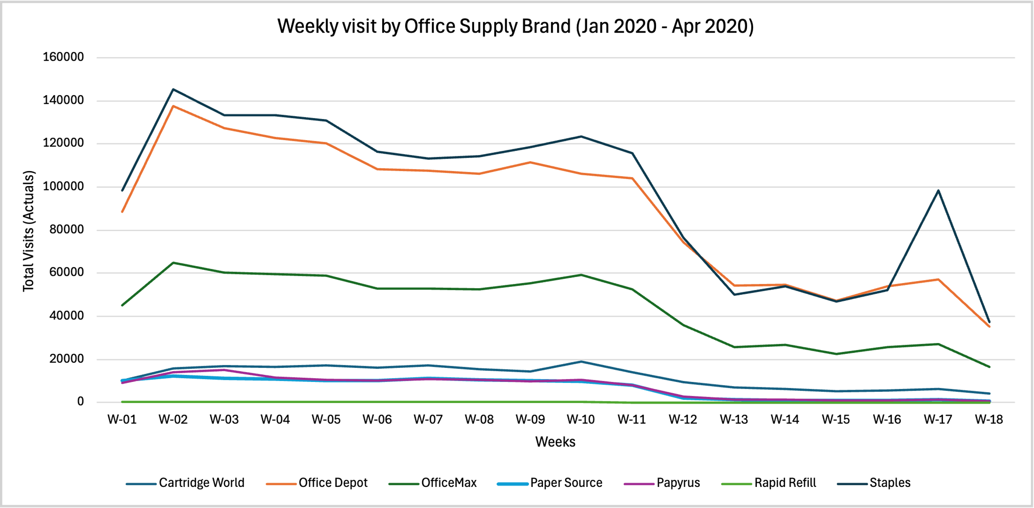
Brand wise Relationship Between Visits and Dwell Time
Insights
1 | Staples and Office Depot dominate in visits but have shorter dwell times (quick, frequent trips).
2 | Specialty stores like Papyrus, Cartridge World, and Rapid Refill attract fewer visitors but with longer dwell times, indicating more focused, high-intent purchases.
3 | Rapid Refill shows the highest dwell time (≈50 mins), showing deep engagement despite low traffic

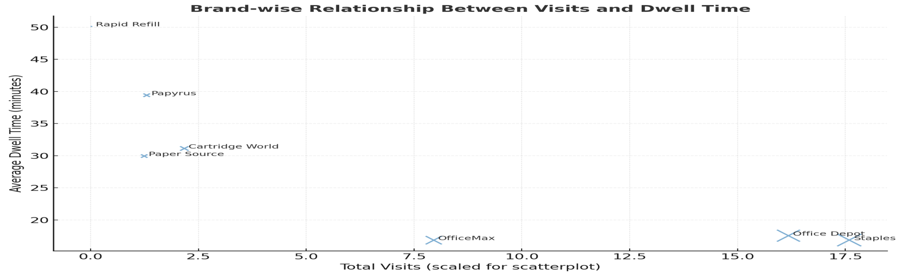

Visits vs. K–12 Population
Insight: Office retailers cluster near suburban, family-oriented populations, demand driven by school and home-office needs.
Brand | K–12 Pop* | Visits | Observation
Staples | 2.4M | 1.76M | Strong presence in family-dense areas.
Office Depot | 2M | 1.62M | Similar correlation, more students → more visits.
Papyrus | 92K | 130K | Smaller K–12 population → fewer school-supply driven visits.
*CBG: Census Block Group

Dwell Time vs. Working-Age Population
Insight: Counties with higher working-age density (urban/suburban) show shorter dwell times, likely due to faster shopping habits and limited time.
Brand | Working-Age Pop. | Avg. Dwell Time | Observation
Staples | 10.65M | 16.8 | Large workforce → fast purchases.
Cartridge World | 2.05M | 31.1 | Moderate engagement; specialty product line encourages longer visits.
Papyrus | 0.74M | 39.7 | Smaller workforce → more leisurely shopping.

Education vs. Engagement
Insight: Longer dwell times are found in regions with a higher concentration of bachelor’s and master’s degree holders, possibly reflecting higher disposable income and preference for personalized shopping.
Brand | Bachelor’s | Master’s | Dwell Time | Observation
Staples | 28,52,879 | 13,08,031 | 16.8 | Serves mixed-education, efficiency-oriented consumers.
Paper Source | 5,00,716 | 3,02,610 | 29.9 | Operates in highly educated areas, consistent with creative, boutique-style shopping.
Papyrus | 3,13,082 | 2,01,086 | 39.7 | Highly educated consumer base with longer in-store exploration.

Conclusion: Consumers in suburban, working-age regions prioritized quick, goal-oriented purchases at high-traffic retailers like Staples and Office Depot, while shoppers in highly educated, smaller markets spent more time exploring specialty stores like Papyrus and Paper Source, reflecting a clear divide between efficiency-driven and experience-driven shopping behaviors.

- Did suburban counties experience a stronger rise in visits at office supply stores than urban centers during the first wave of remote work?

Insights
1 | Suburban counties showed the highest visits and engagement, led by Staples and Office Depot, indicating faster recovery after the remote work shift.
2 | Urban areas had slightly lower visits but similar dwell times, reflecting quicker, goal-oriented trips, while rural areas saw fewer visits but longer stays.
3 | Specialty brands like Papyrus and Rapid Refill recorded lower traffic yet higher dwell times, suggesting more purposeful, high-value purchases.
4 | Hotspots such as Los Angeles County, CA, highlight where office-supply demand remained strongest during early 2020.
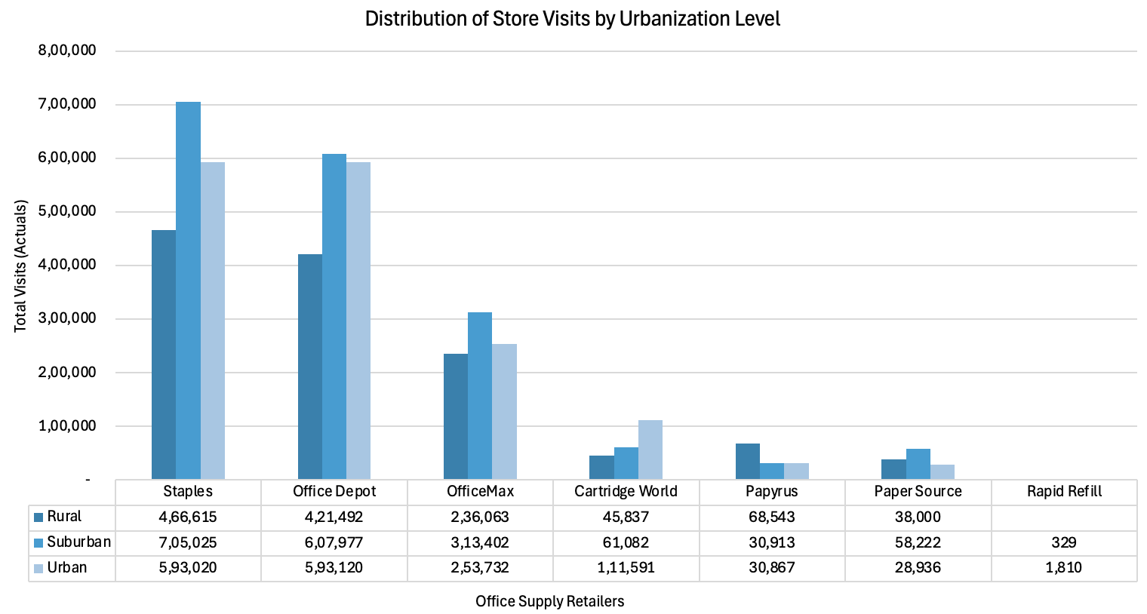
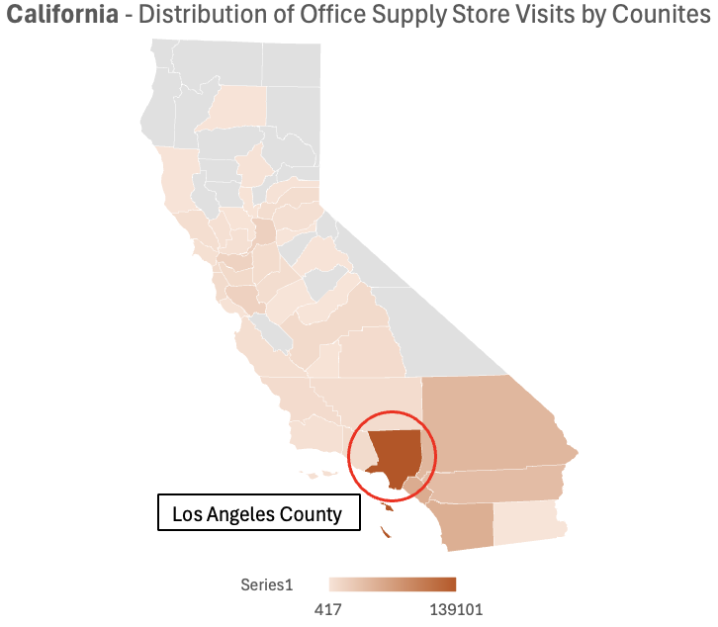
Conclusion: The findings confirm that suburban counties experienced a stronger rise in visits and dwell times at office supply stores compared to urban centers during the first wave of remote work. This reflects how suburban consumers adapted faster to home-office needs, driving early in-store recovery and shaping new post-pandemic retail dynamics.
- Did certain office supply brands experience faster stabilization in visits and dwell times than others during the first four months of 2020, and what might this suggest about brand loyalty and essential purchasing behaviour?

We’re looking at two key behavioral metrics:
Visits: Foot traffic to store locations | Dwell Time: Average time spent per visit.

Staples and Office Depot show early stabilization around Weeks 16–17, with visits rebounding by ~20–25%. Staples’ quick rebound (jump from 47 K to 98 K weekly visits by Week 17) highlights its perception as an essential retailer, customers returned as soon as stores reopened. OfficeMax follows a delayed pattern.

Brand | Stabilization Week | Recovery Pattern | Key Interpretation
Staples | WK 16–17 | Rapid rebound after steep mid-March dip | Strong brand loyalty and essential status drove early recovery; demand tied to home-office setup.
Office Depot | WK 17–18 | Gradual recovery and steady visits | Maintained consistent customer base; reflects reliability and convenience as essential retailer.
OfficeMax | WK 18 | Slower, moderate rebound | Some brand overlap with Office Depot may have diluted traffic; secondary player in essential category.
Cartridge World | WK 17 | Partial stabilization | Specialized product line led to moderate rebound; supported by printer and cartridge needs for remote work.
Paper Source | No clear stabilization | Visits remained low through April | Non-essential, creative products saw sustained decline; recovery delayed by reduced in-store browsing.
Papyrus | No clear stabilization | Continued decline post-March | Discretionary gifting and stationery purchases collapsed; slow adaptation to online demand.
Rapid Refill | Minimal activity | Stable at very low volume | Niche audience with deep but narrow engagement; limited market reach and low recovery potential.

Final Statement

We identified Staples as the top brand, with Los Angeles County, CA, standing out as the key hotspot for office supply demand. Suburban regions and essential retailers led the early recovery, revealing how consumers prioritized convenience and home-office readiness during the remote work shift.

Artificial Intelligence Support Statement

Our team used Artificial Intelligence (AI) tools such as ChatGPT and Perplexity AI to support our project work. These tools helped us debug and refine and comment SQL queries, summarize research findings, and improve the clarity and structure of our report. We also used AI to check code logic, fix syntax errors, and make our explanations easier to understand.
AI tools were used only as assistants, not as replacements for our own analysis or decision-making. Every AI-generated suggestion was reviewed, verified, and modified by group members to ensure the accuracy, originality, and quality of our final work. We carefully validated all data processing steps, analytical results, and written content before including them in this report.
Overall, AI support helped us save time, improve clarity, and enhance technical accuracy, while our team maintained full control and responsibility for the methods, analysis, and interpretations presented in this project.
Example prompts used during the project included:
SQL Development & Debugging
- “Suggest SQL queries to calculate weekly visits and dwell times from SafeGraph data.”
- “Debug this SQL error in BigQuery when joining visits and brands tables.”
- “How can we convert visits_by_day arrays into daily records using UNNEST?”
- “Write a query to classify visits by urban, suburban, and rural counties.”
- “Create an SQL structure to join SafeGraph data with demographic variables like K–12 population and working-age cohorts.”
Data Analysis & Insights
- “Summarize trends in office supply store visits during the first four months of 2020.”
- “What do dwell time differences suggest about consumer behavior?”
- “Identify which brands recovered fastest in visits and dwell time after the COVID-19 dip.”
- “Explain the difference between high-traffic and high-engagement store types.”
- “How can suburban vs. urban traffic patterns reflect essential versus discretionary behavior?”
Writing & Report Development
- “Write a short, clear research question for our SafeGraph analysis.”
- “Draft an overview describing how remote work impacted office supply demand.”
- “Create a concise conclusion summarizing suburban recovery and brand loyalty.”
- “Polish and simplify this AI support statement for professional tone.”
- “Summarize key insights from weekly visits data for Staples, Office Depot, and Paper Source.”
Visualization & Presentation
- “Suggest the best chart types to show stabilization and dwell time differences.”
- “Generate a bubble chart comparing total visits and dwell time by brand.”
- “Help design slide titles and structure for a final presentation deck.”

Exploratory Data Analysis Query Log (Examples)
-- ------------------------------------------------------------------
-- Identify where office supply stores are most concentrated
-- ------------------------------------------------------------------
SELECT
p.region AS state,
COUNT(DISTINCT p.safegraph_place_id) AS num_stores
FROM `group7-fa25-mgmt58200-final.safegraph.places` AS p
WHERE p.naics_code = 453210
GROUP BY state
ORDER BY num_stores DESC
LIMIT 10;
-- ------------------------------------------------------------------
-- Get central tendency of store performance
-- ------------------------------------------------------------------
SELECT
AVG(v.raw_visit_counts) AS avg_visits_per_record,
APPROX_QUANTILES(v.raw_visit_counts, 2)[OFFSET(1)] AS median_visits,
AVG(v.median_dwell) AS avg_dwell_time_minutes,
APPROX_QUANTILES(v.median_dwell, 2)[OFFSET(1)] AS median_dwell_time
FROM `group7-fa25-mgmt58200-final.safegraph.visits` AS v
JOIN `group7-fa25-mgmt58200-final.safegraph.places` AS p
ON v.safegraph_place_id = p.safegraph_place_id
WHERE p.naics_code = 453210;
-- --------------------------------------------------------------
-- Compute the average daily visits and median dwell time
-- --------------------------------------------------------------
SELECT
AVG(v.raw_visit_counts) AS avg_daily_visits,
AVG(v.median_dwell) AS avg_dwell_minutes
FROM `group7-fa25-mgmt58200-final.safegraph.visits` v
JOIN `group7-fa25-mgmt58200-final.safegraph.places` p
ON v.safegraph_place_id = p.safegraph_place_id
WHERE p.naics_code = 453210;
-- --------------------------------------------------------------
-- Find which states saw the highest traffic during Jan–Apr 2020
-- --------------------------------------------------------------
SELECT
p.region AS state,
SUM(v.raw_visit_counts) AS total_visits
FROM `group7-fa25-mgmt58200-final.safegraph.visits` v
JOIN `group7-fa25-mgmt58200-final.safegraph.places` p
ON v.safegraph_place_id = p.safegraph_place_id
WHERE p.naics_code = 453210
AND v.date_range_start BETWEEN '2020-01-01' AND '2020-04-30'
GROUP BY state
ORDER BY total_visits DESC
LIMIT 10;

Final Research Questions Query Log

Question1: -
-- --------------------------------------------------------------
-- Create aggregated brand-level visit summary table
-- --------------------------------------------------------------
CREATE TABLE `group7-fa25-mgmt58200-final.safegraph.tot_visit_brand_Step1` AS
SELECT b.brand_name,
SUM(v.raw_visit_counts) AS total_visits,
AVG(v.median_dwell) AS avg_dwell_time, -- average of median dwell times (approx)
SUM(v.raw_visit_counts) / POW(10, 5) AS total_visits_for_scatterplot -- scaled value for visualization
FROM
`group7-fa25-mgmt58200-final.safegraph.visits` AS v
INNER JOIN
`group7-fa25-mgmt58200-final.safegraph.brands` AS b
ON v.safegraph_brand_ids = b.safegraph_brand_id
WHERE
b.naics_code = 453210 -- Office supply & stationery stores
GROUP BY
b.brand_name
ORDER BY
total_visits DESC;
-- Optional: Preview the result
-- SELECT * FROM `group7-fa25-mgmt58200-final.safegraph.tot_visit_brand_Step1`;

-- =====================================================================
-- Aggregate weekly visits and average dwell time by brand, enriched with demographic attributes (K–12, working-age, education)
-- =====================================================================
-- -----------------------------------------------------------
-- STEP 1: Extract and parse daily visit data from SafeGraph
-- -----------------------------------------------------------
WITH parsed AS (
SELECT
v.date_range_start,
v.date_range_end,
b.brand_name,
v.poi_cbg, -- Census block group identifier
ARRAY(
SELECT SAFE_CAST(x AS INT64)
FROM UNNEST(SPLIT(REGEXP_REPLACE(v.visits_by_day, r'[\[\]\s]', ''), ',')) AS x
) AS visits_array, -- Convert string array to integer array
v.median_dwell -- Median dwell time per visit record
FROM
`group7-fa25-mgmt58200-final.safegraph.visits` AS v
INNER JOIN
`group7-fa25-mgmt58200-final.safegraph.brands` AS b
ON
v.safegraph_brand_ids = b.safegraph_brand_id
WHERE
b.naics_code = 453210 -- Filter for office supply stores
),

-- -----------------------------------------------------------
-- STEP 2: Expand the array into daily visit rows
-- -----------------------------------------------------------
expanded AS (
SELECT
brand_name,
poi_cbg,
TIMESTAMP_ADD(date_range_start, INTERVAL pos DAY) AS visit_date,
value AS visits,
median_dwell
FROM
parsed,
UNNEST(visits_array) AS value WITH OFFSET AS pos
),
-- -----------------------------------------------------------
-- STEP 3: Aggregate to weekly level
-- -----------------------------------------------------------
weekly_visits AS (
SELECT
brand_name,
poi_cbg,
DATE_TRUNC(DATE(visit_date), WEEK(MONDAY)) AS week_start,
SUM(visits) AS weekly_visits,
AVG(median_dwell) AS avg_dwell_time
FROM
expanded
WHERE
visit_date >= TIMESTAMP('2020-01-01 05:00:00 UTC')
AND visit_date < TIMESTAMP('2020-05-01 00:00:00 UTC')
GROUP BY
brand_name, poi_cbg, week_start
),
-- -----------------------------------------------------------
-- STEP 4: Prepare demographic data by Census Block Group (CBG)
-- -----------------------------------------------------------
cbg_demogs AS (
SELECT
cbg,
-- K–12 population (ages 5–17)
(`pop_m_5-9` + `pop_m_10-14` + `pop_m_15-17` +
`pop_f_5-9` + `pop_f_10-14` + `pop_f_15-17`) AS k12_population,

-- Working-age population (ages 18–64)
(`pop_m_18-19` + `pop_m_20` + `pop_m_21` + `pop_m_22-24` + `pop_m_25-29` +
`pop_m_30-34` + `pop_m_35-39` + `pop_m_40-44` + `pop_m_45-49` +
`pop_m_50-54` + `pop_m_55-59` + `pop_m_60-61` + `pop_m_62-64` +
`pop_f_18-19` + `pop_f_20` + `pop_f_21` + `pop_f_22-24` + `pop_f_25-29` +
`pop_f_30-34` + `pop_f_35-39` + `pop_f_40-44` + `pop_f_45-49` +
`pop_f_50-54` + `pop_f_55-59` + `pop_f_60-61` + `pop_f_62-64`) AS working_age_population,
-- Education level counts
edu_hs AS edu_high_school,
edu_coll_assoc AS edu_associates,
edu_coll_bach AS edu_bachelor,
edu_coll_mast AS edu_masters
FROM `group7-fa25-mgmt58200-final.safegraph.cbg_demographics`
)
-- -----------------------------------------------------------
-- STEP 5: Join weekly visit data with demographics and summarize by brand
-- -----------------------------------------------------------
SELECT
w.brand_name,
SUM(w.weekly_visits) AS total_weekly_visits,
AVG(w.avg_dwell_time) AS avg_dwell_time,
SUM(d.k12_population) AS total_k12_population,
SUM(d.working_age_population) AS total_working_age_population,
SUM(d.edu_high_school) AS total_high_school,
SUM(d.edu_associates) AS total_associates,
SUM(d.edu_bachelor) AS total_bachelor,
SUM(d.edu_masters) AS total_masters
FROM
weekly_visits AS w
LEFT JOIN
cbg_demogs AS d
ON
w.poi_cbg = d.cbg
GROUP BY
w.brand_name
ORDER BY
total_weekly_visits DESC;

Question 2: -
-- =====================================================================
-- STEP 1: Create a clean, weekly aggregated dataset for office supply visits
-- =====================================================================
-- Drop the table if it already exists (to avoid duplicates)
DROP TABLE IF EXISTS `group7-fa25-mgmt58200-final`.safegraph.Wekly_visit_Step_2;
-- Create a new table for weekly visit summaries
CREATE TABLE `group7-fa25-mgmt58200-final`.safegraph.Wekly_visit_Step_2 AS
WITH
parsed AS (
SELECT
v.postal_code,
v.date_range_start,
v.date_range_end,
b.brand_name,
-- Convert visits_by_day string (e.g., "[1, 2, 3, ...]") into an integer array
ARRAY(
SELECT SAFE_CAST(x AS INT64)
FROM UNNEST(SPLIT(REGEXP_REPLACE(v.visits_by_day, r'[\[\]\s]', ''), ',')) AS x
) AS visits_array
FROM
`group7-fa25-mgmt58200-final`.safegraph.visits AS v
INNER JOIN
`group7-fa25-mgmt58200-final`.safegraph.brands AS b
ON
v.safegraph_brand_ids = b.safegraph_brand_id
WHERE
b.naics_code = 453210 -- Filter for office supply stores
),

-- =========================================================
-- EXPANDED: Unnest daily visits into one row per day
-- =========================================================
expanded AS (
SELECT
postal_code,
brand_name,
date_range_start,
date_range_end,
-- Add the daily offset (pos) to get the actual visit date
TIMESTAMP_ADD(date_range_start, INTERVAL pos DAY) AS visit_date,
value AS visits
FROM
parsed,
UNNEST(visits_array) AS value WITH OFFSET AS pos
),
-- =========================================================
-- WEEKLY_AGG: Aggregate daily visits into weekly totals
-- =========================================================
weekly_agg AS (
SELECT
postal_code,
brand_name,
DATE_TRUNC(DATE(visit_date), WEEK(MONDAY)) AS week_start,
SUM(visits) AS weekly_visits
FROM
expanded
WHERE
visit_date >= TIMESTAMP('2020-01-01 05:00:00 UTC') -- Filter for 2020 and beyond
GROUP BY
postal_code, brand_name, week_start
),
-- =========================================================
-- RANKED_WEEKS: Assign week numbers for each brand
-- =========================================================
ranked_weeks AS (
SELECT
postal_code,
brand_name,
week_start,
-- Generate week labels (e.g., W-01, W-02, ...)
CONCAT(
'W-',
LPAD(CAST(ROW_NUMBER() OVER (PARTITION BY brand_name ORDER BY week_start) AS STRING), 2, '0')
) AS week_number_padded,
-- Sequential week number for ordering
ROW_NUMBER() OVER (PARTITION BY brand_name ORDER BY week_start) AS week_sequence_num,
weekly_visits
FROM
weekly_agg
)

-- =========================================================
-- FINAL OUTPUT: Weekly visits by brand and postal code
-- =========================================================
SELECT
postal_code, -- Postal code (location)
brand_name, -- Brand (e.g., Staples, Office Depot)
week_start, -- Week start date
week_number_padded AS week_number, -- Week label (e.g., W-01)
weekly_visits -- Aggregated weekly visit count
FROM
ranked_weeks
ORDER BY
brand_name, week_sequence_num; -- Order by brand and week

-- =====================================================================
-- STEP 2: Create a table summarizing weekly visits by Urban/Rural class
-- =====================================================================
-- Drop table if it already exists (to prevent duplication)
DROP TABLE IF EXISTS `group7-fa25-mgmt58200-final`.safegraph.Wekly_visit_U_R_indicator;
-- Create a new table to aggregate weekly visits by urban classification
CREATE TABLE `group7-fa25-mgmt58200-final`.safegraph.Wekly_visit_U_R_indicator AS
SELECT
b.urban_class, -- Urban/Suburban/Rural classification
a.postal_code, -- Postal code of the visit record
a.brand_name, -- Office supply store brand name
SUM(a.weekly_visits) AS weekly_visits -- Total weekly visits aggregated by postal code
FROM
`group7-fa25-mgmt58200-final`.safegraph.Wekly_visit_Step_2 AS a
LEFT JOIN
`group7-fa25-mgmt58200-final`.safegraph.county_classification AS b
ON
a.postal_code = b.postal_code
-- Optional filter (uncomment to analyze a specific brand)
-- WHERE a.brand_name = 'Rapid Refill'
GROUP BY
b.urban_class,a.postal_code,a.brand_name
ORDER BY
b.urban_class,a.brand_name;

Question 3: -
-- =====================================================================
-- PURPOSE:
-- Analyze weekly and monthly trends in foot traffic and dwell time
-- for office supply stores (NAICS 453210) during Jan–Apr 2020.
-- Calculates absolute and percent change in visits and dwell times.
-- =====================================================================

-- -----------------------------------------------------------
-- STEP 1: Parse visits_by_day into arrays of daily visit counts
-- -----------------------------------------------------------
WITH parsed AS (
SELECT
v.date_range_start,
b.brand_name,
-- Convert visits_by_day string (e.g., "[1, 2, 3]") into numeric array
ARRAY(
SELECT SAFE_CAST(x AS INT64)
FROM UNNEST(SPLIT(REGEXP_REPLACE(v.visits_by_day, r'[\[\]\s]', ''), ',')) AS x
) AS visits_array,
v.median_dwell
FROM
`group7-fa25-mgmt58200-final`.safegraph.visits AS v
INNER JOIN
`group7-fa25-mgmt58200-final`.safegraph.brands AS b
ON
v.safegraph_brand_ids = b.safegraph_brand_id
WHERE
b.naics_code = 453210 -- Office Supply category
AND DATE(v.date_range_start) >= DATE('2020-01-01') -- Start of analysis window
AND DATE(v.date_range_end) < DATE('2020-05-01') -- End of analysis window
),
-- -----------------------------------------------------------
-- STEP 2: Expand daily visit arrays into one row per day
-- -----------------------------------------------------------
expanded AS (
SELECT
brand_name,
TIMESTAMP_ADD(date_range_start, INTERVAL pos DAY) AS visit_date,
value AS visits,
median_dwell
FROM
parsed,
UNNEST(visits_array) AS value WITH OFFSET AS pos
),
-- -----------------------------------------------------------
-- STEP 3A: Aggregate daily visits to weekly totals
-- -----------------------------------------------------------
weekly AS (
SELECT
brand_name,
DATE_TRUNC(DATE(visit_date), WEEK(MONDAY)) AS period_start,
SUM(visits) AS visits,
AVG(median_dwell) AS dwell
FROM
expanded
GROUP BY
brand_name, period_start
),
-- -----------------------------------------------------------
-- STEP 3B: Aggregate daily visits to monthly totals
-- -----------------------------------------------------------
monthly AS (
SELECT
brand_name,
DATE_TRUNC(DATE(visit_date), MONTH) AS period_start,
SUM(visits) AS visits,
AVG(median_dwell) AS dwell
FROM
expanded
GROUP BY
brand_name, period_start
),
-- -----------------------------------------------------------
-- STEP 4A: Compute week-over-week changes
-- -----------------------------------------------------------
weekly_changes AS (
SELECT
brand_name,
period_start,
visits AS current_visits,
LAG(visits) OVER (PARTITION BY brand_name ORDER BY period_start) AS previous_visits,
dwell AS current_dwell,
LAG(dwell) OVER (PARTITION BY brand_name ORDER BY period_start) AS previous_dwell
FROM
weekly
),
-- -----------------------------------------------------------
-- STEP 4B: Compute month-over-month changes
-- -----------------------------------------------------------
monthly_changes AS (
SELECT
brand_name,
period_start,
visits AS current_visits,
LAG(visits) OVER (PARTITION BY brand_name ORDER BY period_start) AS previous_visits,
dwell AS current_dwell,
LAG(dwell) OVER (PARTITION BY brand_name ORDER BY period_start) AS previous_dwell
FROM
monthly
)
-- -----------------------------------------------------------
-- STEP 5: Combine weekly and monthly change results
-- -----------------------------------------------------------
SELECT
'week' AS period_type,
brand_name,
period_start,
previous_visits,
current_visits,
current_visits - previous_visits AS visits_change,
SAFE_DIVIDE(current_visits - previous_visits, previous_visits) AS visits_pct_change,
previous_dwell,
current_dwell,
current_dwell - previous_dwell AS dwell_change,
SAFE_DIVIDE(current_dwell - previous_dwell, previous_dwell) AS dwell_pct_change
FROM
weekly_changes

UNION ALL

SELECT
'month' AS period_type,
brand_name,
period_start,
previous_visits,
current_visits,
current_visits - previous_visits AS visits_change,
SAFE_DIVIDE(current_visits - previous_visits, previous_visits) AS visits_pct_change,
previous_dwell,
current_dwell,
current_dwell - previous_dwell AS dwell_change,
SAFE_DIVIDE(current_dwell - previous_dwell, previous_dwell) AS dwell_pct_change
FROM
monthly_changes

ORDER BY
brand_name,
period_type,
period_start;

